TASK-2-Implement git ignore command to ignore unwanted files and folders

Step 1- Create new new directory named gitignoreDemo

mkdir gitignoreDemo

Step-2 Change the directory

Cd gitignoreDemo

Step -3 Initialize the Git

Git init

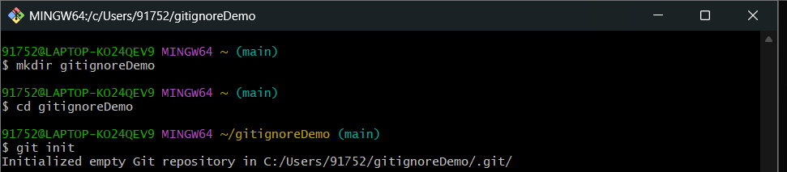

Step-4 Create Unwanted Files

Eco “This is a log file” >debug.log

Mkdir.log

Echo “old logs here”> log/system.log

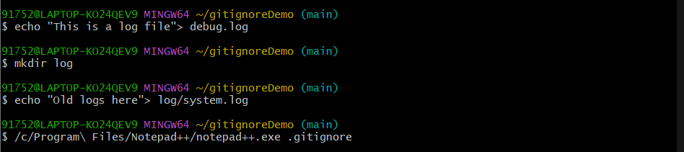

Step -5

Open gitignore in Notepad++

/c/Program\ Files/Notepad++/notepad++.exe .gitignore

Step-6 check the git status

Git status

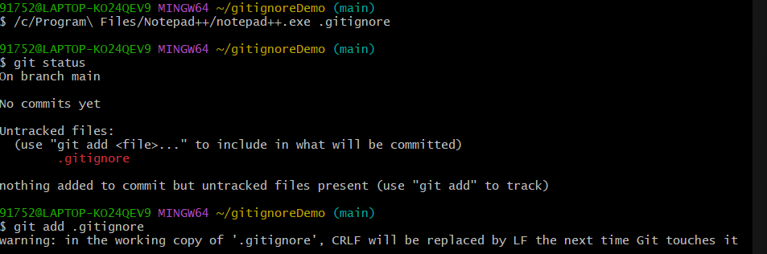

Step- 7 – Commit Changes

Git add .gitignore

Git commit -m “Added .gitignore to ignore .log files and log folder”

Step-8 Check the status

Git status

